SESSION — ACTIVITY (20 MIN) • STUDENT HANDOUT • SLOT D
Redesign the Misleading Colored Chart
R.No: 40 Reg. No: 192525102 Name: Yashika R
Each chart below uses color in a misleading or confusing way. For each one, answer the three questions in your own words.
Chart 1
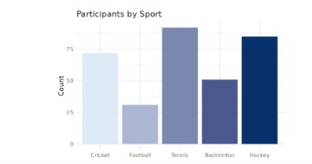
1. What is this chart trying to show?
It shows the number of participants in different sports such as Cricket, Football, Tennis, Badminton, and Hockey.
2. What's wrong with the color choice?
The bars use different shades of blue, which can make the chart look unnecessarily varied. The colors do not represent any meaningful category or value and may distract from comparing the bar heights.
3. Propose a better color scheme:
Use one consistent color for all bars, such as medium blue. If highlighting one particular sport is necessary, use blue for all bars and a contrasting color such as orange for the selected sport.
Chart 2
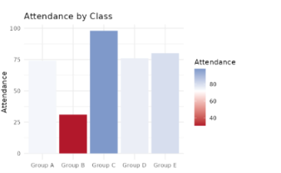
1. What is this chart trying to show?
It shows the attendance levels of students in different classes, from Group A to Group E.
2. What's wrong with the color choice?
The chart uses a red-to-blue color scale for attendance, even though the bars already show attendance through their heights. The red color can also suggest a warning or poor performance, which may be misleading.
3. Propose a better color scheme:
Use one consistent color, such as blue, for all classes. Alternatively, use a simple sequential color scale from light blue for lower attendance to dark blue for higher attendance, so the colors naturally represent increasing values.

